Great Lakes Bay Region STEM Access & Equity Initiative

- Request for Mini Grant Proposals

Introduction
The Great Lakes Bay Region Early Childhood STEM Access and Equity Initiative aims to mitigate Science, Technology, Engineering and Math (STEM, including Arts or STEAM) access and equity barriers for at-risk early childhood youth (ages 0-8) and their families. This will be accomplished by leveraging existing community assets and creating new sustainable STEM learning partnerships between student-serving organizations, STEM-rich institutions and families.

Based on a regional STEM asset survey conducted in 2016, our initiative would capitalize on existing resources in the community. These assets would include STEM-rich institutions such as museums, planetarium, zoo, libraries, outdoor education and nature centers, community centers, summer camps, and mobile labs/programs that go to schools and early education centers. In terms of a “STEM learning ecosystem,” these are all part of the out-of-school time STEM learning space that your projects could maximize.

Improved STEM access and equity will be accomplished via competitive mini-grants to encourage long-term, sustainable partnerships between student-serving organizations and STEM-rich institutions. Student-serving organizations, such as before/after school programs, child care centers, preschools, K-3 schools, etc. will partner with STEM-rich institutions to co-develop, design and implement their projects. The mini-grants will be used to offset programming costs and remove barriers such as admission and/or transportation for the at-risk students. Moreover, in addition to collecting and reporting on a common set of evaluation measures, each project would be required to report on outcomes unique to their project and offer free admission coupons and/or STEM passports to families for return visits and subsequent STEM learning experiences.

Purpose of Mini Grants
The primary purpose of this mini-grant funding is to provide STEM access and equity opportunities to underserved populations, including minority groups, girls, rurally-isolated students, and children living in poverty. There are approximately 50,000 children ages 0-8 in the 8 counties within prosperity region 5. Roughly one-third of those students are from low-income households with a range of 21% in Midland County to 38% in the Clare-Gladwin RESD. The project is inspired by the Equality of Opportunity Project (http://www.equality-of-opportunity.org/), including the article America’s Lost Einsteins, and the recent research from the Center for Childhood Creativity, “The Roots of STEM Success: Changing Early Learning Experiences to Build Lifelong Thinking Skills.” Both bodies of research clearly demonstrate the immense need to address STEM access for at-risk children and the need to mitigate access and equity with an upstream approach, very early in a child’s life.

Your proposed projects will also help to vertically and horizontally align instructional practices, STEM experiences and math/science curricula. It aims to better connect in-school formal learning with out-of-school time learning, reducing a phenomenon known as “random acts of STEM.” The funding should intentionally seek to align instructional practices, experiences, and math and science curriculum across our STEM-learning ecosystem.

Finally, your projects should purposefully bolster families’ awareness of STEM opportunities, encourage parental involvement in their children’s education and mitigate barriers for families who wish to access STEM-rich institutions across the Great Lakes Bay Region.

What inspired the access/equity efforts and mini-grants?

The overarching initiative was inspired by a recent study from the Equality of Opportunity project, where a team of Stanford economists found that children from families in the top 1% of income distribution are 10 times more likely to have filed for a patent as those from below-median-income families, and that white children are three times as likely to have filed a patent as black children. This led to a series of subsequent news stories in December 2017 related to “America’s Lost Einsteins” published in The Atlantic, New York Times, a CBS news story, and other media outlets.

In addition, the initiative was inspired by the Center for Childhood Creativity, “The Roots of STEM Success: Changing Early Learning Experiences to Build Lifelong Thinking Skills.” This article demonstrates that children actually spend the majority of their early life and K-3 years out of school, with their families and in a wide array of informal settings. This is a missed window of opportunity to capitalize on a child’s rapid brain development and propensity for skill acquisition.
As a result of this recent research, poor academic and economic outcomes for at-risk populations, and many other anecdotes from our region concerning the lack of STEM opportunities and access afforded to at-risk children, we are proposing the Great Lakes Bay Region Early Childhood STEM Access and Equity Initiative.

Your proposed projects will seek to:
- Mitigate STEM access and equity challenges for at-risk groups across the region
- Reduce random acts of STEM (lack of alignment to standards and coherency)
- Improve early childhood academic math and science outcomes; school readiness
- Improve future STEM talent needed for a dynamic and rapidly changing economy
- Increase families’ awareness of the importance of STEM and local STEM assets
- And, better connect our regional STEM Learning Ecosystem!

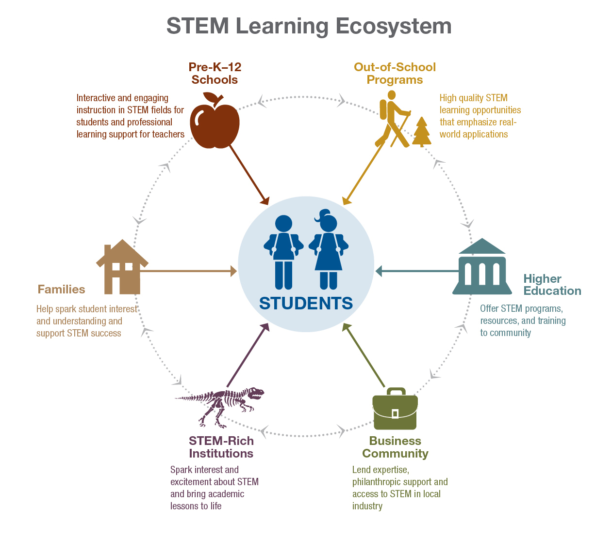
Source: http://innovation.ed.gov/2015/11/19/communities-come-together-to-support-stem-education/

Target populations include the following:
- Schools with high free/reduced lunch rates and minority populations (Preschool & K-3)
- Rural areas in the eight (8) counties that have high poverty rates
- Title 1 school buildings (Preschool, K-3)
- Child care programs (or consortium of child care programs) with least 30% of families utilizing the DHHS Child Development and Care (CDC) subsidy
- Head Start, Early Head Start and Great Start Readiness Programs
- Saginaw Neighborhood Associations with afterschool and summer programs
- Other non-profit organizations serving a high percentage of minority populations
- Saginaw Indian Chippewa Tribe and Saganing (Isabella and Standish/Arenac County)

This project falls under the existing work of the Great Lakes Bay Region STEM Impact Initiative and the Out-of-School Time STEM Network, including our efforts as part of the international STEM Learning Ecosystems Community of Practice.

Your proposed projects will focus on three overarching goals (as described to our funders):
1. Mitigate STEM access and equity challenges for at-risk groups across the region.
2. Improve early childhood academic math and science outcomes.
3. Increase families’ awareness of the importance of STEM and local STEM assets.

Goal 1: Mitigate STEM access and equity challenges for at-risk groups across the region.

Objective 1: By January 1, 2020, 5-10 mini grants will have been funded to create new partnerships between student-serving organizations and STEM-rich institutions to assist more than 200 children and their families to access a continuum of high quality STEM experiences.

Goal 2: Improve early childhood academic math and science outcomes.
Objective 2: By January 1, 2020, 5-10 projects will submit their evaluations detailing math and science learning outcomes for their respective STEM programs.

Goal 3: Increase families’ awareness of the importance of STEM and local STEM assets.

Objective 3: By January 1, 2020, participating families will report a 25% increase in their awareness of the importance of STEM and a 20% increase in their knowledge of STEM-rich institutions across the Great Lakes Bay Region.

Mini-grant description:
Your mini-grants (if funded) will include high quality partnerships between student-serving organizations and STEM-rich institutions that are: long-term, aligned to the Michigan/Next Generation Science Standards (NGSS), age-appropriate, intentionally scaffolded, and sustainable.

Each mini-grant will have a common set of expectations. For example, there is an expectation that programming, activities, lessons and evaluations will be co-designed by the student-serving organization/s and STEM-rich institution/s (including the community and parents, where possible). Moreover, applicants would need to include “pre-learning activities” prior to any “field trips or on-site events” and “post-learning activities” that would be sustained afterwards. There would be an expectation that post-event activities would occur to offer reflection and further extend the STEM learning, coupled with efforts to strengthen relationships with parents and family engagement by offering coupons for subsequent visits and/or STEM passport booklets.
Again, each project will have an evaluation component, collect data, and demonstrate math and science learning outcomes, i.e., pre and post-test evaluation to benchmark academic gains, etc. Applicants would want to consider partnering with higher education institutions, ISDs and other research organizations to collect and report outcomes data.
Parents/families are critical partners to improve child development and child outcomes. As referenced earlier, we seek upstream solutions leveraging brain science, out-of-school time, and families to improve the whole STEM Learning Ecosystem. Therefore, an added feature of all projects would include the distribution of coupons for subsequent free visits to the STEM-rich institutions. In addition, as a separately funded part of our overall strategy, we wish to develop and distribute STEM passport booklets to promote other STEM-rich institutions. If the STEM passport booklets are funded and made available during our window of programming, these would naturally be given to our participating families.

Finally, all mini-grant applicants will need to identify their targeted number of families, provide demographic information, and provide a strategy on how they would work with families to ensure future access and equity issues are mitigated.

- Timetable for implementation

We intend to award mini-grant requests by November/December of 2018, with 5-10 mini-grant funding requests reviewed and approved for implementation between December 2018 and January 1, 2020. A second round of mini-grant requests for proposals (RFPs) may be available in the spring of 2020. All mini-grant programming and activities will take place between December 2018 and completed by January 1, 2020. Evaluation outcomes and final mini-grant expenses and activity reports would be due by February 2020.

See below for a sample of potential partners and applicants, who have been part of the Out-of-School Time STEM Network (Note: This is not a comprehensive or exclusive list of eligible applicants):

Examples of Student-Serving Organizations - Partners in the Region
- All after school programs, child care centers, preschools, kindergarten and early elementary grades across the Great Lakes Bay Region with a high percentage of at-risk children/students
- Boys & Girls Clubs of the Great Lakes Bay Region
- The ROCK Center for Youth Development
- Bay City Public Schools 21st Century Program/Before & After School
- Clare-Gladwin SPARKS Program
- Boy Scouts of America - STEM
- Girl Scouts & STEM
- Greater Midland Community Center, West Midland & North Midland Family Centers
- First Ward Community Center
- Dow Bay Area Family Y
Examples of STEM-Rich Institutions - Partners in the Region
- Midland Center for the Arts
- Dow Gardens
- CMU Museum of Cultural & Natural History
- Mt. Pleasant Discovery Museum
- Delta College Planetarium & Learning Center
- Delta College STEM Explorer Bus
- SVSU Marshall M. Fredericks Sculpture Museum
- SVSU Greenhouse
- CMU Center for Excellence in STEM Education
- Bay County Historical Museum, Imagination Playground Block Shop
- Castle Museum
- Standish Historical Center & Depot
- Northeast Michigan Arts Council
- Mid-Michigan Children's Museum
- American Chemical Society - Midland Section
- American Foundry Society
- Bay Sail
- Children's Zoo at Celebration Square
- Saginaw Library
- Beaverton Activity Center
- Bay County Library System (3D printing program, etc.)
- MSU Research Center - Midland
- Engineering for Kids
- Chippewa Nature Center
- Hartley Outdoor Education Center
- Forest Hill Nature Center
- Bay City State Recreation Area
- U.S. Fish & Wildlife Service, Green Point Nature Center
- Shiawassee National Wildlife Refuge
- Empey Learning Zone
- All Summer Camps and Summer STEM Programs
Keep in mind, there are existing model programs in the region that helped to inform this Request for Proposals. Existing models include the Saginaw Children’s Zoo at Celebration Square and their “Grow Program” and “Living & Learning Lab.” The Mid-Michigan Children’s Museum has partnerships with area schools and 2nd grade teachers called, “Properties of Air and Water,” including lessons and field trip experiences. And, Midland Center for the Arts and the Chippewa Nature Center have existing partnerships that were used to help guide our efforts.
- You may wish to reach out to these colleagues for ideas and suggestions.
Scoring and mini-grant reviewers:
Volunteers will include the Great Lakes Bay Region STEM Steering Committee to assist with communicating and promoting the request for proposals, helping to review and score applications, make funding decisions, reviewing evaluation findings, and communicating evaluations findings to our respective constituents.
NOTE: Please reference the Grant Application Evaluation Rubric, which will be used to help score the applications and make funding decisions.

- Long-term strategies for funding this project at the end of the grant period

In terms of sustainability, this project is aimed at building long-term partnerships between STEM-rich institutions and student-serving organizations. The project achieves this by intentionally having the respective staff work together to co-author the mini-grant applications, co-design the projects, co-design the evaluation, collaborate on program implementation, collaborate to engage families, and do follow-up outreach with parents. This will build strong inter-relationships between the staff of the student-serving organizations and STEM-rich institutions, linking the organizations. By virtue of this intentional cross-sector organizational linking and better connecting them to their community, we feel that the programs will have an increased likelihood of success, support and future funding.

- Should you have questions, please contact:

- Lori Flippin, STEM Impact Initiative Leader, 989-695-6100, lflippin@greatlakesbay.org
- Rich VanTol, Out-of-School Time STEM Network Leader, 989-233-8729, vantolr@baisd.net

